**DUNDALK INSTITUTE OF TECHNOLOGY**

**Technical Documentation On**

**WRISTBAND AIR QUALITY MONITOR**

Project Carried Out

**By**

**D00251785 PATRICK ORJIEH**

**D00244618 ROBERT NUGENT**

**D00261104 CONOR MC GINN**

**D00240060 HANNAH MC ELROY**

Under the Supervision of

**DR. JOHN LOANE**

DEPARTMENT OF COMPUTING AND MATHEMATICS

**SCHOOL OF INFORMATICS AND CREATIVE ARTS**

**DEPARTMENT OF VISUAL AND HUMAN CENTERED COMPUTING**

**Security and Privacy**

**Device Security:**

The first feature that we will be implementing in order to support device security is a 4-digit pin for the device. When first using the wristband, the user will be prompted to setup a 4-digit PIN which will be used in the future to gain access to the device when attempting to connect to it. This will prevent anyone from connecting to the device and tampering with it.

To build on the security of this PIN, we will also implement a device lockout system. Whenever the user enters the PIN incorrectly 5 times then the device will be locked and not allow any access to it until the lock is lifted. When the device becomes locked, an email will be sent to the email address associated with the device with an option to unlock the device. By using this system. It will prevent unauthorized users to have an infinite number of tries at bypassing the PIN to access the device.

Another feature that we are designing that will increase the level of security for the device is a way for the user to remotely wipe or lock the device if they lose it. Once the device becomes lost, it will be vulnerable if found by someone else. To counter this, we will allow the user to lockdown their lost device from their current location using the app so that no one will be able to access it and tamper with it. As well as this, the user could wipe all of their data from the device and essentially reset it so that if someone would gain access to it, they wouldn’t be able to see any of their data.

**Data in transfer security:**

The main way that we are going to keep data safe in transfer is through end-to-end encryption. This means that the data will be encrypted before it is transmitted and will only be decrypted once it has reached its destination. There are a lot of different ways to do this but the way which we plan on doing it is through the use of a strong encryption algorithm called AES, which stands for Advanced Encryption Standard. We have decided to use this specific algorithm as it is considered to be highly secure and efficient which will highly contribute to the overall security and performance of the system.

Another way to improve the security of the data is by carrying out data integrity checks. To ensure that the data was not messed with during transfer, we must check the integrity of the data once it is received by the server. We can do this by using cryptographic hashes. When the data is hashed using a hash function, a hash value is produced. This value will be sent with the data to the server so that the server can compare the received hash value with the one that it gets from carrying out the hash function itself. If the hash values match, then the data has not been messed with, otherwise, the data isn’t the same as what was originally sent.

Finally, we will make use of tokens during data transfer for authentication reasons. Tokens are important for authenticating the users who will be carrying out these data transfers. By using tokens, we can ensure that the user has appropriate permissions to carry out what they are trying to do as well as determine if they are a valid user or not. If the token hasn’t expired and is has been verified, then the action relating to data transfer will be performed.

**Data in storage:**

While in storage, we will be encrypting data to make it more secure. It’s important that we encrypt personal data such as emails and passwords as we don’t want such information to end up leaked or stolen. Other than specifically encrypting, we can keep some of the data secure using methods such as password hashing and salting.

Another way of keeping the data safe while in storage is by enforcing strict access control. By using access control, we only allow certain authenticated users access to the data and decide which of these users will be able to modify this data. We will only allow each user the exact permissions that they will need to carry out their task and nothing more than that. We will be basing the access control on user roles so that each user has the appropriate permissions for their role and responsibilities.

We will also be backing up the data frequently to ensure that we maintain data integrity. There is always a chance that data can become corrupted, or a problem will arise with it and we want to have a solution for this. By backing up the data, we will easily be able to restore it when something like this happens. This will make data recovery easier and will stop us from losing data in these events while also improving the integrity of the data.

**UI, User and testing**

**Registration & Login:**

When a user first opens the application, they will be presented with the log in page. If the user has an account and knows their password then they can simply input their details and click the ‘LOGIN’ button, which will take them to the main functionality of the app.

If it is there first time using the app they will need to create an account, they can do this by clicking the ‘Sign Up’ button at the bottom of the page. Doing this will take them to the Create Account page where they can fill in their personal details and then submit them using the ‘Register’ button.

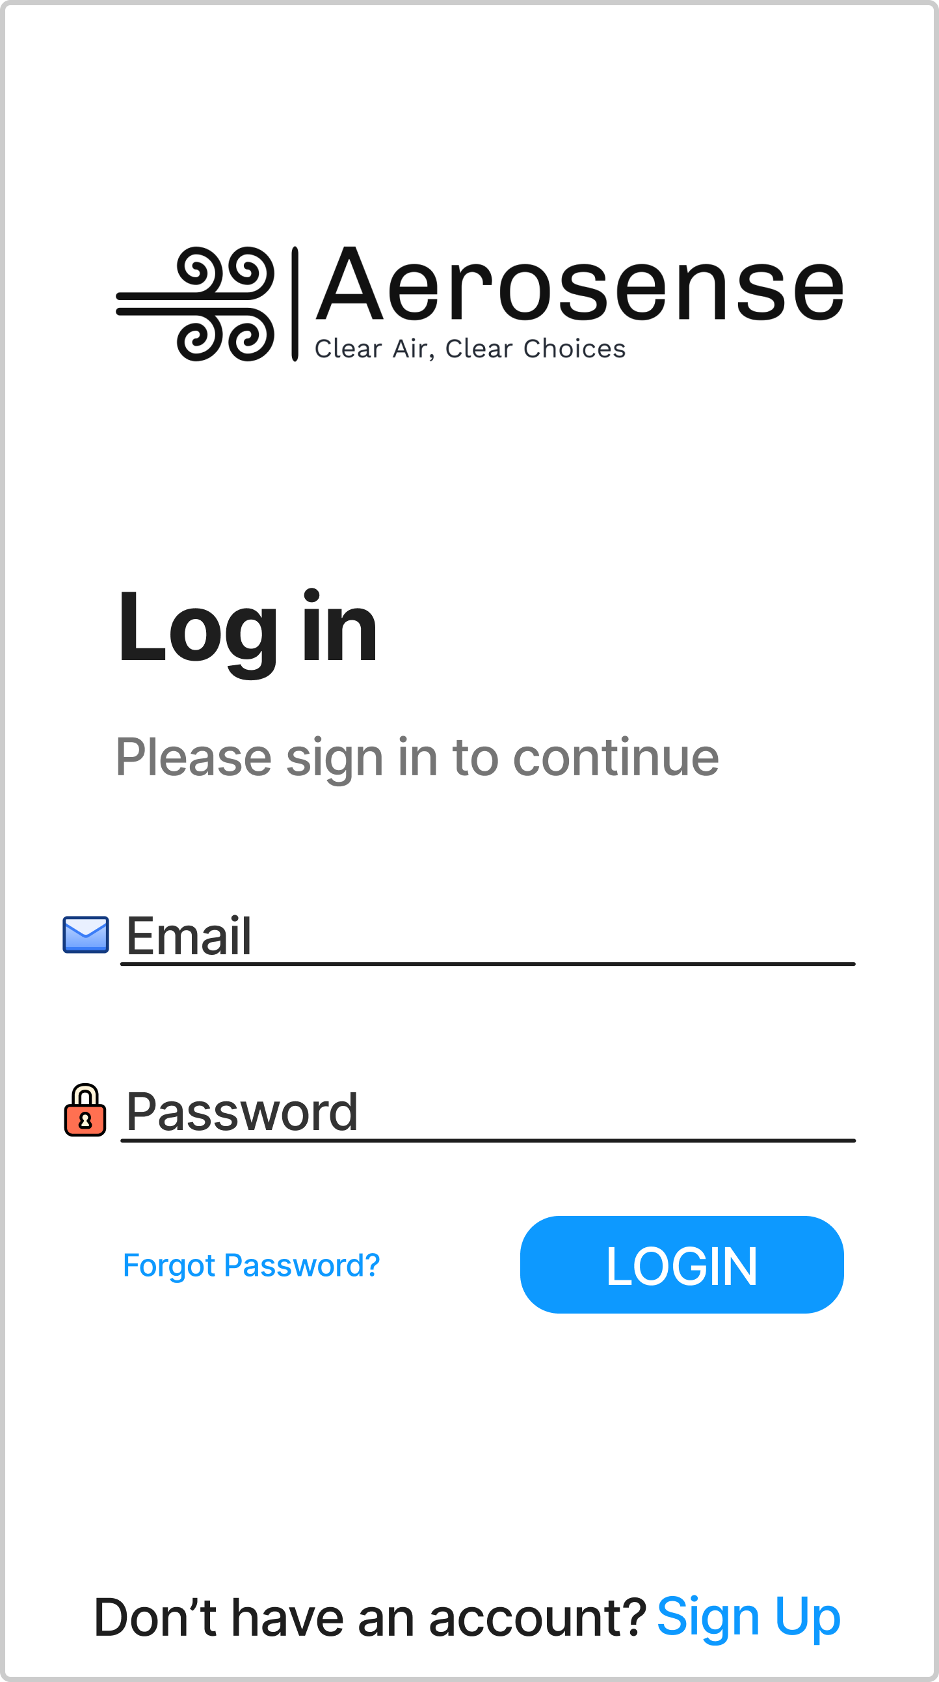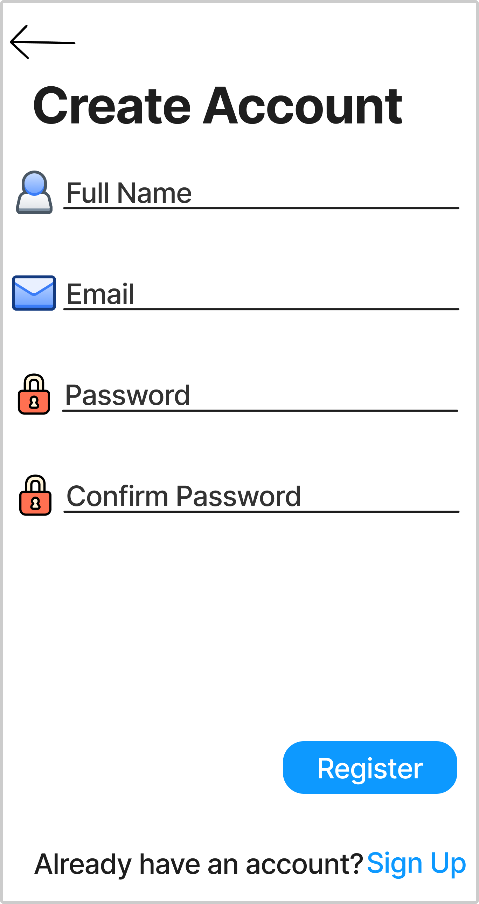

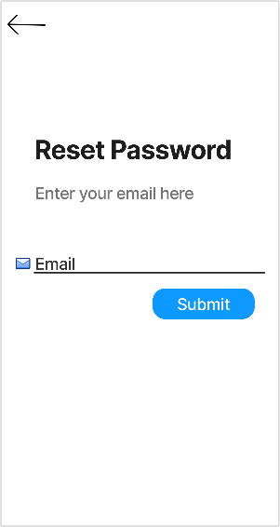If the user has account but cannot remember their password, they can then click the ‘Forgot Password’ button on the login page. This will take them to the Reset password page where they can enter the email they previously signed up with and hit submit. This will send an email to the account where they can set a new password for the account.